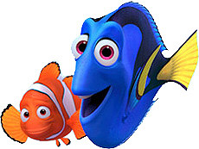
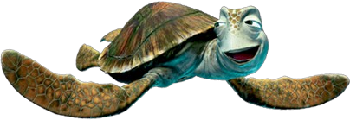
“Finding Nemo” Animal Kingdom Test

- Name the phylum and class that Marlin and Coral (the clownfish) are classified under.
  - Phylum: _______________
  - Class: _________________

- What type of organism do Marlin and Coral live within? ________________________
  - This animal belongs to this phylum: _______________________
  - The phylum name means: ________________________________
  - Another example of an organism from this phylum would be: ____________________________

- How do Marlin and Coral reproduce? _______________________________________
  - What type of fertilization? Internal External

- When Nemo is getting ready to go to school, what type of animal does he get stuck in? ______________
  - Name two characteristics of this animal
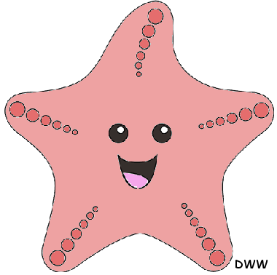

- The school teacher is what type of fish? ______________________________
  - Phylum: _____________________
  - Class: _______________________
  - Does he have a swim bladder? Yes No

- The pink animal that ‘inks’ itself is what kind of animal? ______________________________
  - Phylum: _____________________________

- What special organ helps boney fish float? ___________________________________

- Bruce, Anchor, and Chum are what type of animals? __________________________________
  - Class: _______________________________________
  - Bones are made of: _____________________________
  - Do they have a swim bladder? Yes No
  - What does Bruce detect with his special chemoreceptors at the end of his head? _____________

- What kind of animals is Marlin’s joke about? _______________ and __________________
  - Phylum of #1: ______________________
  - Phylum of #2: ______________________

- During the fish tank scene, what kind of animal is:
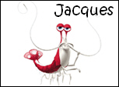
  - Peach: __________________ Belongs to phylum: ___________________
  - Jacques: __________________ Belongs to phylum: ____________________
  - Nigel: ____________________ Belongs to class: _____________________
  - Darla: ____________________ Belongs to class: ______________________

- The story takes place in Australia. What type of unusual mammals can be found there that are not usually found elsewhere?
  - Example of Monotreme: ________________________________
  - Example of Marsupial: _________________________________

- What organ does the school of fish use to move as one group? ____________________________
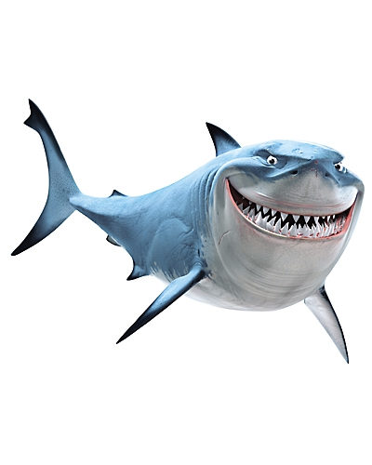
- What type of animal is swimming over the trench? ________________________
  - Phylum: ____________________
  - Where are the stinging cells located? __________________________
  - If Dory were human, what could she have done to stop the stinging of her wound? ___________________________________________________________________

- What type of animal is Crush? ____________________________
  - Phylum: ________________________
  - Class: __________________________
  - How was his son, Squirt, born? ________________________________________

- What kind of animal gives Marlin and Dory an unusual ride to Sydney? ______________________
  - Class: _____________________________________
  - Is example of: Monotreme Marsupial Placental Boney Fish Cartilaginous Fish
  - How does this kind of animal breathe? Gills Lungs
  - What does this particular animal eat? ____________ Belongs to phylum:___________________
  - What are the 3 categories within this phylum? Circle the answer that the whale’s food belongs in.
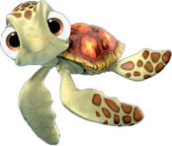
    - _______________________________
    - _______________________________
    - _______________________________

- The seagulls and pelicans have what type of egg production? _____________________________
  - Eggs are also similar to what other animal in the movie: ________________________________
  - The reason why the birds can fly is because they have: _______________and______________
  - Feathers are actually modified _____________________________________
  - The reason why the seagulls can keep saying “MINE” over and over again is because birds are the only animals that can: _____________________________________________________

17. Could Nemo really survive in tap water? Yes No
a. Why?

- The animals located on top of the pipe that Nemo finally comes out of are _______________________
  - If they were to lose an appendage, what would eventually happen?________________________
  - This process is called: ___________________________________________________________

- The fish that get caught in the boat’s net, would you consider them a social group? Why?

- If you look closely at Marlin and Nemo, the animators did not include what major organ on these fish?
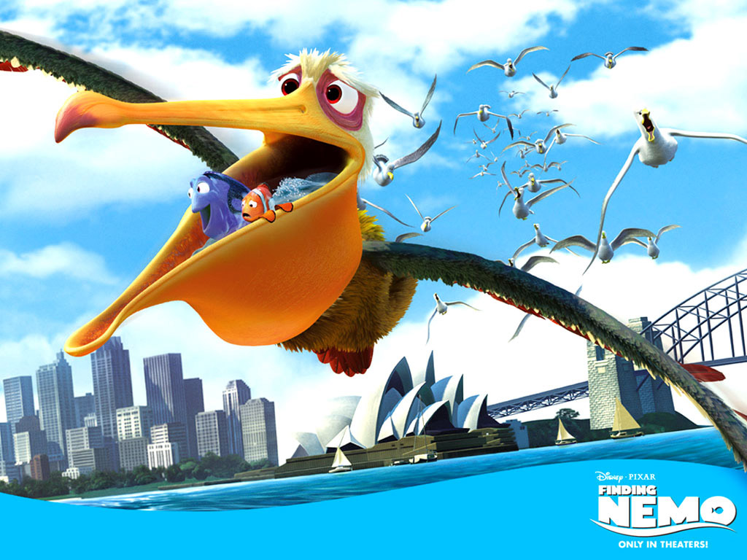
21. What 2 classes of vertebrates are not included in this film?
a. _________________________________________
b. _________________________________________

- Give 3 examples of animals from the film that are ectothermic:

23. Give 3 examples of animals from the film that are endothermic:

- Give an example of an animal from the film that display each type of body symmetry:
None: ________________ Radial: ________________ Bilateral: ________________

